|  |
| --- |
| University of Colorado Boulder |
| Global Engineering Artifact Project Proposal |
| Connecting students with the world through technology |

|  |
| --- |
| Will Derryberry, Blain Vannice, Audrey Randall, Soham Shah, Darwin Wood, Ian Murphy, Sam Thornton, Mackinley Kath, Shannon Hessler, Charlie Vail, and Connor Cheek, Sean Downs  5/19/2015 |

# Table of Contents

Table of Contents 1

Table of Figures 1

Table of Tables 1

Introduction 2

Artifact Description 3

Interactive Display 3

Location of Display 4

Projector 5

Kinect Sensor 7

Computer 7

GPS Receiver 8

Cables and Connections 9

App 10

Project Timeline and Key Deliverables 12

Project Budget 13

Primary Stakeholders 14

# Table of Figures

Figure 1: Ubi Interactive Screen while touching the wall 3

Figure 2: Ubi Interactive with Air Gestures rotating a plane model with a fist 3

Figure 3: It is easy to set up Ubi Interactive software. 4

Figure 4: The interactive screen will replace the Welcome to Kitt Bulletin Board 4

Figure 5: The chosen wall is located between the primary doors to the building. 5

Figure 6: The Kinect could be hung from the leading edge of the wood paneling. 7

Figure 7: The computer's location behind the desk is circled in red. 8

Figure 8: BU-353-W GPS receiver and USB connector 9

Figure 9: Connection Diagram 10

Figure 10: Screenshot of the App's Homepage 11

# Table of Tables

Table 1: Computer Components Cost 8

Table 2: Cable Connections 9

Table 3: Timeline and Key Milestones 12

Table 4: Artifact Budget 13

# Introduction

Technology is changing our world. Things that were difficult or impossible in the past are becoming a reality. Thoughts and ideas are shared instantly across the globe. In our Age of Information, businesses and cultures are expanding across borders bringing diverse individuals from numerous backgrounds together in ways that were not previously possible. These individuals have many different values and identities, and it is critically important to understand and respect these values and identities. By connecting people with these ideas, they will grow their understanding of the world and succeed in their endeavors.

The Global Engineering Artifact will connect the students and visitors in Kittredge Central Residence Hall (Kitt Central) at CU with the identities and ideas of the world. Using an interactive screen controlled by air gestures, users will interact with a projected screen to learn about these ideas and identities. Located in a public space near the desk in the south wing of Kitt Central, the artifact will have high exposure to the students living in the building and create an exciting atmosphere at the desk. In addition to the residents, hundreds of prospective students will experience by the artifact as they head to the showroom in Kitt Central during campus tours. They will notice that atmosphere and see the exciting possibilities that come from living in the residence halls at CU.

10 years ago, the interactive screens from films were science fiction. However, what was science fiction then is possible and affordable now. The screen, running a custom app, incorporates current events, numerous languages, live news feeds, and global concepts. The user simply swipes their hands in the air in front of the screen to engage the app.

Designed and built by engineering students in the Global Engineering Residential Academic Program (Global Engineering RAP), this project provides them an exciting opportunity to invest in, connect to, and strengthen their community outside of classes. Furthermore, these students are learning the fundamentals of team-oriented project design, which is an essential skill for their degree.

Assistance from Housing and Dining and Facilities Management will be needed for the initial installation of the artifact. A bulletin board currently mounted on the wall will need to be removed. The projector will also need to be mounted on the wall and powered from an outlet. After the initial installation, the artifact will require minimal maintenance. The Global Engineering RAP pledges to maintain the artifact, and neither Housing and Dining or Facilities Management will be expected to assist. Considerable efforts have been made to design a reliable and low maintenance artifact. The maintenance and operation of the artifact will be documented, so students from the Global Engineering RAP in future years can properly service and run the artifact.

Funding for this project will primarily come from the Global Engineering RAP. Dr. Diane Sieber, the Director of the Global Engineering RAP, has reserved up to $6,000 of RAP funds for this project. The estimated cost of the artifact currently is $3,000.

Design of the artifact began in September 2014. In the spring of 2015, parts will be ordered and the artifact will be installed. After several weeks of testing and debugging, the artifact will be ready for an official unveiling. The target completion date for this project is May 1, 2015, which is the end of the spring academic semester.

Approval of this project would provide a significant opportunity for the students and guests in Kitt Central to broaden their understanding of the world through cutting-edge technology. By connecting with the ideas and identities of others, they will grow their experiences and be more successful in our evolving world. The opportunities and excitement from the Global Engineering Artifact will demonstrate the passions and communities within the residence halls at CU. This innovative project will inspire current and future students to be global.

# Artifact Description

## Interactive Display

The artifact will contain an interactive projection display. Using software from Ubi Interactive, a Microsoft Kinect, and a computer running Windows 8.1, any projection system can be transformed into an interactive environment. You simply swipe your hands along the wall and the display responds as if it were a touchscreen. The newest version supports Air Gestures, so *one does not even need to touch the wall*. You swipe your hands through the air. This way, the wall will not get dirty from all of the fingerprints of the users. The following figures below show how the software allows you to control the screen. All images are from Ubi Interactive’s [website](http://www.ubi-interactive.com/) or their [YouTube channel](http://www.youtube.com/watch?v=mUpDMIWu6ZI). Figure 1 is from the Ubi Interactive website and show sliding the hands apart on the wall zooms in on the map.

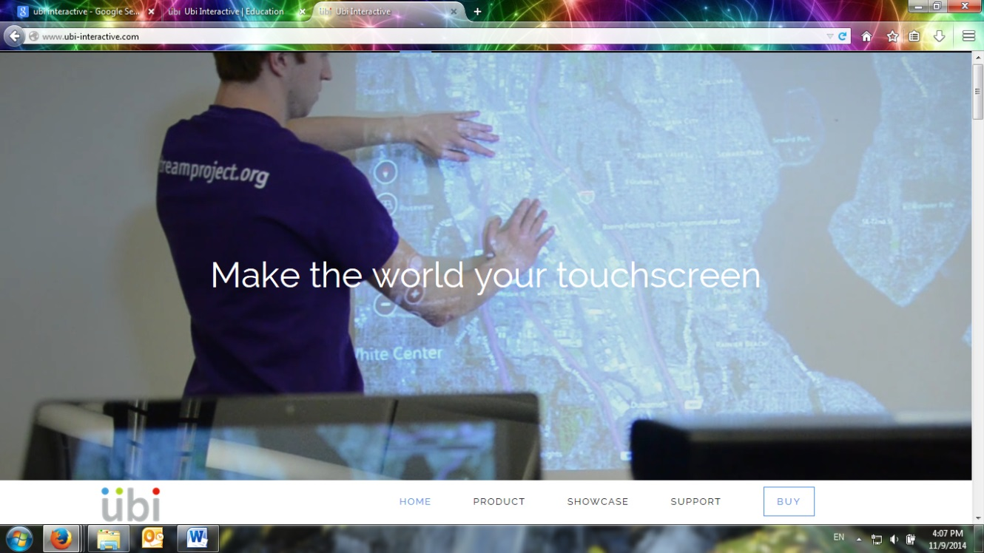

Figure : Ubi Interactive Screen while touching the wall

Figure 2 below is a still from Ubi Interactive’s YouTube channel and show how Air Gestures are used without touching the screen. Here, the man is rotating a model of a plane by moving a fist through the air. The Kinect sensor is black, and it can be seen just below the center of the screen. The Ubi Interactive software with Air Gestures is the best choice for the artifact, because it will keep users from touching the wall producing less wear and less need for cleaning.

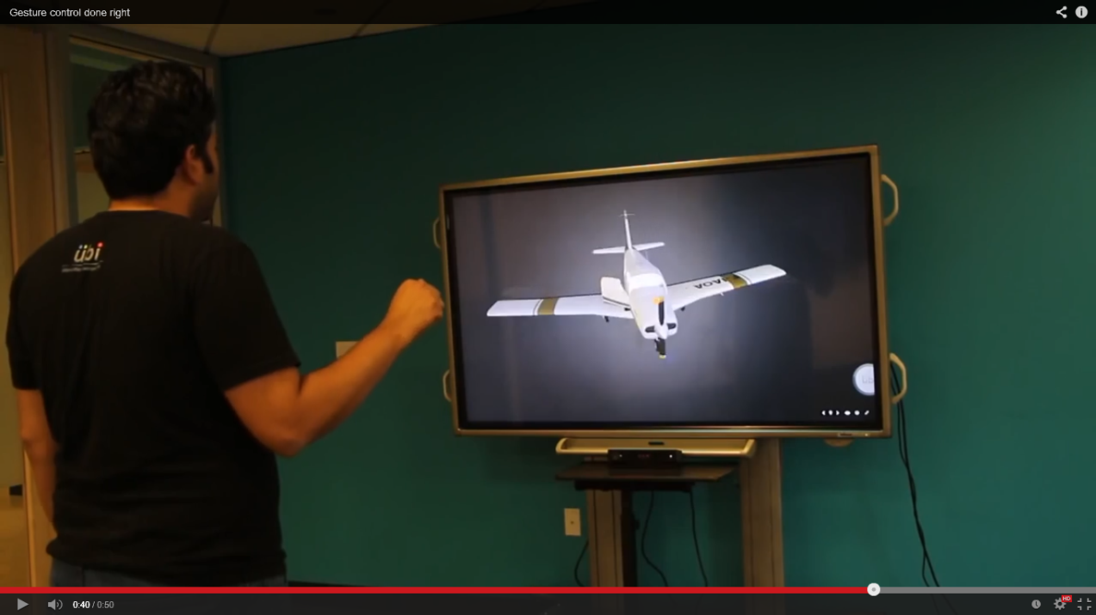

Figure : Ubi Interactive with Air Gestures rotating a plane model with a fist

Figure 3 below illustrates how easy it is to set up an interactive display with the Ubi Interactive software. The artifact will use a Windows V2 Kinect (to support Air Gestures), a PC running Windows 8.1, and projector to display the image on the wall. Details about each component of the set up are described in their respective sections below.

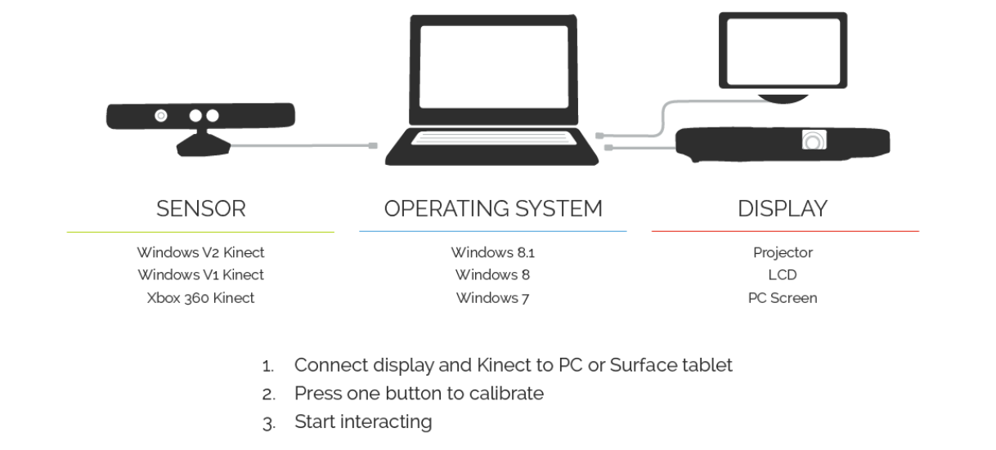

Figure : It is easy to set up Ubi Interactive software.

With the setup described in Figure 3, *any touch-enabled app for Windows 8.1 can be used* and controlled through the interactive screen. Ubi Interactive software costs [$680](http://www.ubi-interactive.com/educate/) with an academic discount for the multi-touch business edition that support taps, swipes, and zooms.

## Location of Display

The artifact will be located at the front desk area of Kitt Central. The interactive display will be on the wall, which currently has the bulletin board that says, “Welcome to Kitt Central”. See Figure 4 below.

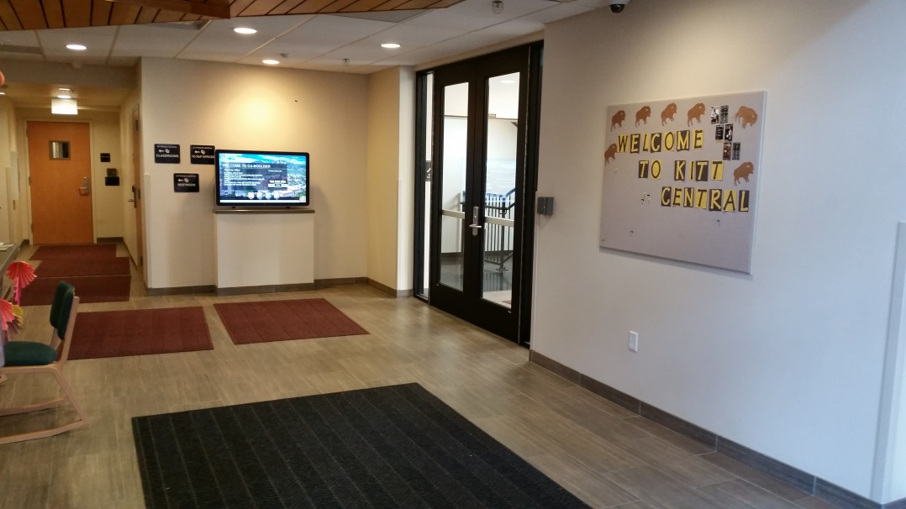

Figure : The interactive screen will replace the Welcome to Kitt Bulletin Board

This bulletin board will need to be removed to have a clear image on the wall. This wall was chosen for the display because it is centrally located and all students and visitors who enter the building pass by this wall. Figure 5 below shows how the bulletin board on the selected wall is centrally located between the main doors of Kitt Central. Every student and guest entering the south wing of Kitt Central passes through the glass door on the right side of Figure 5. Residents then enter the residential wing by passing through the glass doors in the left side of Figure 5 or the wooden door shown in Figure 4. By placing the artifact on this wall, it will provide a global experience for the greatest number of people.

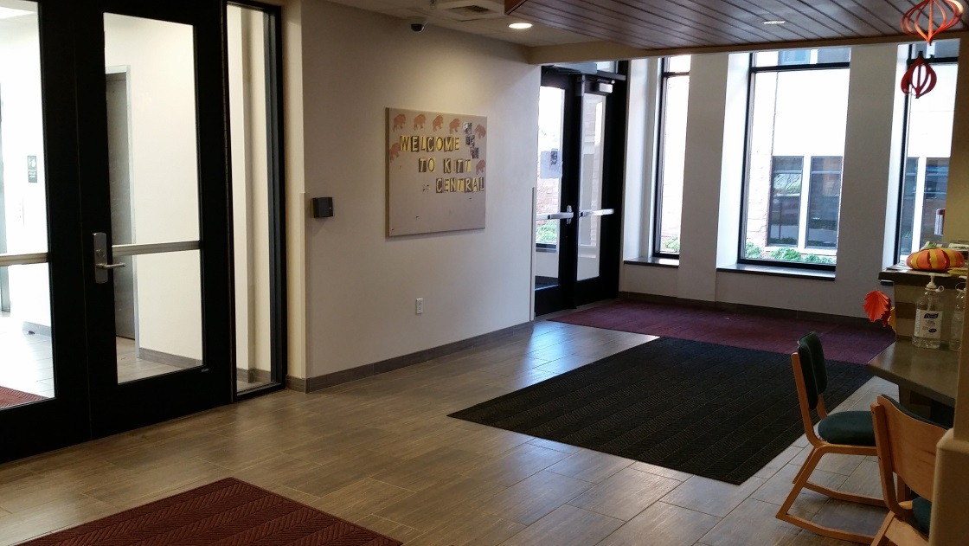

Figure : The chosen wall is located between the primary doors to the building.

Currently, there is a touch screen display in this area of Kitt Central, and it can be seen in Figure 4 above. This is a screen that is provided and managed by Housing and Dining. While the artifact also has an interactive screen, it serves a different purpose that the housing and dining screen. The housing and dining screen provides information about the CU campus and events occurring on campus. The artifact will provide a way for users to connect with the world to discover current global events and to explore multiple languages. Like the housing and dining screen, the artifact will display current new feeds; however, the artifact will *allow the user to select a headline and read the full story*. This will invite the user to think critically about global issues and events. Furthermore, the artifact will display news from several different news agencies in several different languages. This will provided different perspectives on current events, as news in one country is not always news in another. Currently, the housing and dining screen does not support either of these features. Great care will be taken when selecting news agencies to minimize inflammatory and/or insensitive stories. The topics and headlines will be informative, educational, and thought provoking.

## Projector

The projector will be mounted on the same wall as the projection screen. This may sound counterintuitive, but Epson and other projector manufacturers sell projectors that do just this. The *projector mounts on the wall and projects its image below itself on the same wall*. This type of projector is called an ultra-short throw projector, and this type was chosen because it is simpler to install, and the beam or light does not shine in people’s faces as they pass by the desk in Kitt Central. A conventional projector has both of these drawbacks, and would need to be located across the walkway and behind the desk.

The chosen projector is an [Epson PowerLite 585W WXGA](http://www.epson.com/cgi-bin/Store/jsp/Product.do?sku=V11H602020) ultra-short throw projector, and it costs about $1,200 with an academic discount. The projected image can range between 60 inches and 100 inches, which will adequately fill the space on the wall. Assistance from Housing and Dining or Facilities Maintenance will be required to install the projector on the wall, as knowledge of the wall structure and proper inspection will be required.

The other challenge is powering the projector, and there are at least two methods to do this. The design team would appreciate the input of Housing and Dining or Facilities Maintenance as to which method is best for the building. The first method involves connecting the projector to a power outlet on the same wall as the projector. This outlet is near the floor, and the power cord would have to be routed securely around the wall so that the cord does not interfere with the projector. If it is practical, a new plug could be installed up near the projector to eliminate the need to route the cord. This method does not require an extension cord as the projector has a 15 foot power cord, but will likely be more expensive than method 2.

Method 2 for powering the projector involves using a power cord to run above the ceiling tiles to a plug behind the desk. This will require a 40 foot power cord, but it will not make any holes in the existing drywall. This method will be cheaper than method 1, and several other cables, namely internet and video, would need to be routed through the ceiling as well. This method is also visually cleaner. See the

The GPS receiver will need to be located where it can receive good quality signals from the satellites overhead. Near the desk in Kitt Central, preliminary testing has shown that the best location for receiving GPS signals is near the windows in the room behind the Kitt Central desk. Therefore, the GPS receiver will be placed near this window, and the cable will be routed out of the back room and to the computer. This will require a 50 foot female to male USB Type A extension cable, which costs about $20. The BU-353-W costs about $34.

Cables and Connections section for more details on these cables.

The projector bulb will need to be replaced periodically. With the brightest settings, Epson says the bulbs should last for 4,000 hours. The artifact will be running from 7am to 1am (18 hours/day) each day of the academic semester. There are about 16 weeks in an academic semester, so the projector will run for about 4,032 hours during a given year. This means that *the projector bulb will be replaced once a year* (or every two academic semesters) assuming that the projector does not run during the summer months. The projector has an Eco Mode, which extends the life of the bulb up to 6,000 hours by reducing the brightness. With the Eco Mode enabled, the bulb will last three academic semester (or 6,048 hours). If the image can still be clearly seen on the wall in daylight in Eco Mode, then the Eco Mode will be used.

Replacement bulbs cost $79 from [Epson](http://www.epson.com/cgi-bin/Store/jsp/Product.do?BV_UseBVCookie=yes&sku=V13H010L80), and the Global Engineering RAP will pay for the replacement bulbs and change them as needed. Since these projector bulbs contain a small amount of mercury, they will need to be properly disposed of at a hazardous waste facility. The nearest facility is the Hazardous Materials Management Facility at 1901 63rd Street in Boulder, Colorado 80301. *The Global Engineering RAP pledges to undertake this maintenance obligation.*

Epson projectors feature free [software](http://www.epson.com/cgi-bin/Store/support/supDetail.jsp?oid=132642&BV_UseBVCookie=yes&infoType=Downloads&platform=OSF_W_8_1-64) that can be installed on the controlling computer. This software allow the computer to turn the projector on and off programmatically. The projector receives these commands through an Ethernet cable. This software will be responsible for shutting the projector off at 1am and turning it back on a 7am. As this is done automatically, *there is no need for the community assistant or anyone else working the Kitt Central desk to maintain or be responsible for the artifact’s operation*. The artifact and its mount will visually disappear when the projector is off.

## Kinect Sensor

The Microsoft Kinect V2 sensor is an infrared sensing device that can track the movement of hands and fingers. It connects to the computer driving the interactive display with a USB cable, and can be purchased on the [Microsoft Store](http://www.microsoftstore.com/store/msusa/en_US/pdp/Kinect-for-Windows-v2-Sensor/productID.298810500) for $180 (this cost includes a 20% academic discount). The Kinect should be mounted such that it has a clear view of the user’s hands, but will be out of the way of people passing near the projection area. Two possible mounting locations meet this condition. Since the top of the projector mount is flat, the Kinect may be secured to the projector mount with adhesive mounting pads. Should this method prove insufficient, then additional mounting options will be considered. If that location is not satisfactory, then the Kinect may be hung from the leading edge of the wood paneling on the ceiling. Since the wood is antique, no holes will be drilled in the wood. Instead, a thin wire or twine can be looped through the paneling to suspend the Kinect. See Figure 6 below for the leading edge of the wood paneling. The Kinect weighs 2.1 pounds and has dimension of 9.8 inches by 2.6 inches by 2.6 inches.

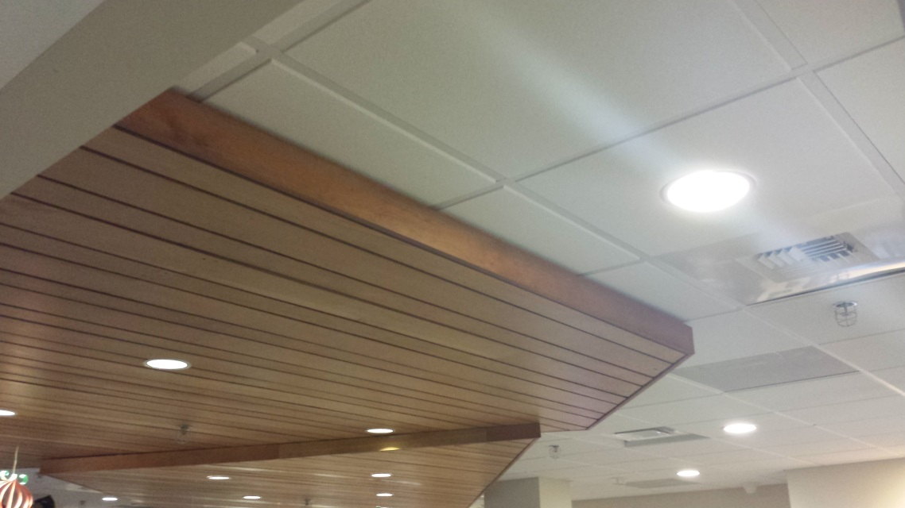

Figure : The Kinect could be hung from the leading edge of the wood paneling.

## Computer

The artifact will be controlled from a computer, which will be located behind the Kitt Central Desk. This computer is connected to the Kinect and the projector, and its runs the App, which is displayed on the screen. The computer will be located behind the Kitt Central Desk in a slot in the corner. In Figure 7 below, the computer would be located in the slot that is circled in red. This space is not currently used, and it is 14 in by 28 in by 19 in. The computer is a tower design, and the case fits within this spot. This computer will be running almost constantly, so extra care was taken to spec a computer that is reliable and properly cooled.

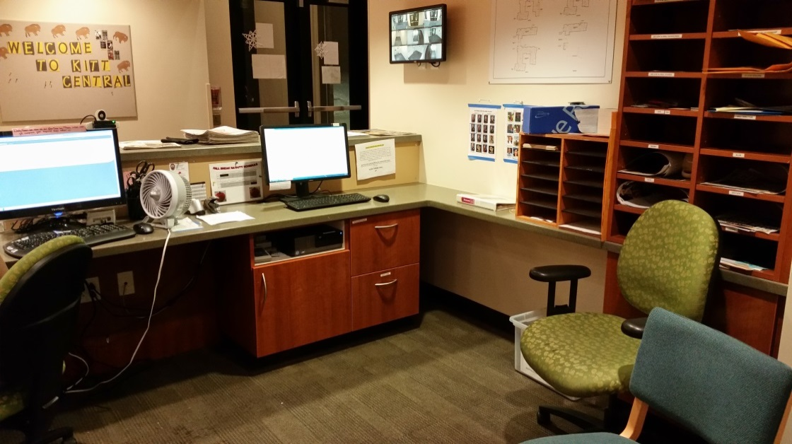

Figure : The computer's location behind the desk is circled in red.

For the initial set up, an extra monitor, that the Global Engineering RAP already owns, will be used. However, this computer will not normally be connected to a monitor, because it prevents unwanted changes to the artifact. The components for this computer are listed in Table 1 below.

Table : Computer Components Cost

|  |  |
| --- | --- |
| GPU-GeForce GT 720 | $60 |
| WD RE2 500 GB internal hard drive Serial ATA-300 3.5’’ 7200 rpm | $45 |
| Raidmax Smilodon atx-612wbp computer case with 500W power supply | $100 |
| Intel® Core™ i5-4690 CPU/MSI Z97-G55 SLI ATX MB/8GB DDR3 1866, Kingston Hyper X Fury Red Memory Bundle | $374 |
| Cooler Master Hyper T2 - Compact CPU Cooler with Dual Looped Direct Contact Heat pipes | $16 |
| **Total** | **$595** |

The total cost of this computer is $595. Building the computer allows for greater component flexibility. For example, the internet card must support two Ethernet channels, one channel to the projector, and one channel to the Ethernet jack in the wall for the campus internet. This is not a standard option on many computers, so building a custom tower allows this part to be included.

Once the computer is built, *it will need a static IP address*, licensed to the Global Engineering RAP. Since all computers on campus are registered to the network, a static IP address allows the artifact’s computer to operate independently of any one student’s registration. This way, if the student graduates or transfers to another school, the artifact will not have to be renewed on the network with another student’s credentials. Furthermore, campus internet users must periodically re-register their computer to maintain access to the internet. A static IP address would free students from manually re-registering the artifact.

## GPS Receiver

As part of the global experience, the artifact will incorporate a GPS receiver. The selected GPS receiver is the [BU-353-W](http://usglobalsat.com/p-62-bu-353-w.aspx#images/product/large/62.jpg) sold by USGlobalSat Inc. The BU-353-W is a GPS receiver that connects to a computer with a USB-A connector, and it is water resistant. See Figure 8 below.

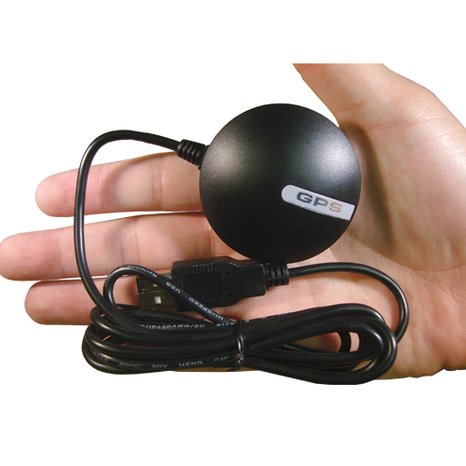

Figure : BU-353-W GPS receiver and USB connector

The GPS receiver will need to be located where it can receive good quality signals from the satellites overhead. Near the desk in Kitt Central, preliminary testing has shown that the best location for receiving GPS signals is near the windows in the room behind the Kitt Central desk. Therefore, the GPS receiver will be placed near this window, and the cable will be routed out of the back room and to the computer. This will require a 50 foot female to male USB Type A extension cable, which costs about [$20](http://www.amazon.com/HDE-High-Speed-480Mbps-Extension-Repeater/dp/B00GLZYG6M/ref=sr_1_cc_1?s=aps&ie=UTF8&qid=1415945186&sr=1-1-catcorr&keywords=50+ft+USB+3.0+Male+to+Female). The BU-353-W costs about [$34](http://www.amazon.com/GlobalSat-BU-353-USB-GPS-Receiver/dp/B000PKX2KA).

## Cables and Connections

Several cables will be needed to connect the various components of the artifact. Some of the cables have been mentioned earlier in this document, but all of the necessary cables are summarized in this section. Table 2 below lists the types of cables needed in the artifact.

Table : Cable Connections

|  |  |  |
| --- | --- | --- |
| **Cable Type** | **Length** | **Connection** |
| Female to Male USB - A Extension | 50 ft | Kinect to Computer (data) |
| Female to Male USB - A Extension | 50 ft | GPS Receiver to Computer (data) |
| HDMI | 50 ft | Computer to Projector (sound and video) |
| CAT 5e Ethernet | 50 ft | Computer to Projector (communication) |
| CAT 5e Ethernet | 25 ft | Computer to Ethernet Jack (internet) |
| Power Cable | 40 ft | Projector to Outlet (power) |

The distance from the projector on the wall to the computer behind the desk is 36 feet. Cable lengths were rounded up to 50 feet to allow for routing through the ceiling and behind the desk. The 25 foot Ethernet cable connects the computer to the Ethernet jack on the wall. Since the both are behind the desk, this cable is shorter than the others are.

A 50 foot HDMI cable costs about [$28](http://www.amazon.com/s/ref=nb_sb_noss_1/186-9274024-1246833?url=search-alias%3Delectronics&field-keywords=HDMI%2050%20feet), and a 50 foot Ethernet cable cost about [$10](http://www.amazon.com/s/ref=sr_nr_n_4?rh=n%3A9938476011%2Ck%3A50+ft+ethernet+cable&keywords=50+ft+ethernet+cable&ie=UTF8&qid=1415332173&rnid=2941120011&ajr=2). The USB cable is an extension on the Type A, male USB port on the Kinect. Therefore, this cable should be 50 foot long with a Type A, female connector on one end and a Type A, male connector on the other end. This USB cable costs about [$20](http://www.amazon.com/HDE-High-Speed-480Mbps-Extension-Repeater/dp/B00GLZYG6M/ref=sr_1_cc_1?s=aps&ie=UTF8&qid=1415945186&sr=1-1-catcorr&keywords=50+ft+USB+3.0+Male+to+Female). The GPS receiver also requires a 50 foot long USB Type A extension cable, which costs an additional [$20](http://www.amazon.com/HDE-High-Speed-480Mbps-Extension-Repeater/dp/B00GLZYG6M/ref=sr_1_cc_1?s=aps&ie=UTF8&qid=1415945186&sr=1-1-catcorr&keywords=50+ft+USB+3.0+Male+to+Female). The 25 foot Ethernet cable costs about [$5](http://www.amazon.com/Ethernet-Cable-CAT5e-25-White/dp/B000E8BGCE/ref=sr_1_5?s=electronics&ie=UTF8&qid=1415945494&sr=1-5&keywords=20+foot+ethernet). The stock power cable that comes with the projector is not long enough if method 2 (described in the Projector section) is used. A longer 40 foot power cable will reach an outlet behind the desk and costs about [$18](http://www.amazon.com/Yard-Master-992382-40-Foot-Extension/dp/B007E8FOMK/ref=sr_1_2?ie=UTF8&qid=1417111575&sr=8-2&keywords=40+foot+extension+cord).

The cables would be routed from the projector on the wall through the ceiling panels and down along the wall near the mailboxes behind the desk. From there, the cables would be routed below the desk to the corner where the computer will be located. Routing through the ceiling appeals in this design, because the cables are out of sight, and no holes need to be made in the walls. The project team will work with Facilities Management to ensure that the cables are routed safely through the ceiling and do not interfere with any other system that may be located above the ceiling panels.

A connection diagram for the artifact is shown below in Figure 9. Solid colored lines indicate a cable connecting two hardware components, which are shown in dashed boxes.

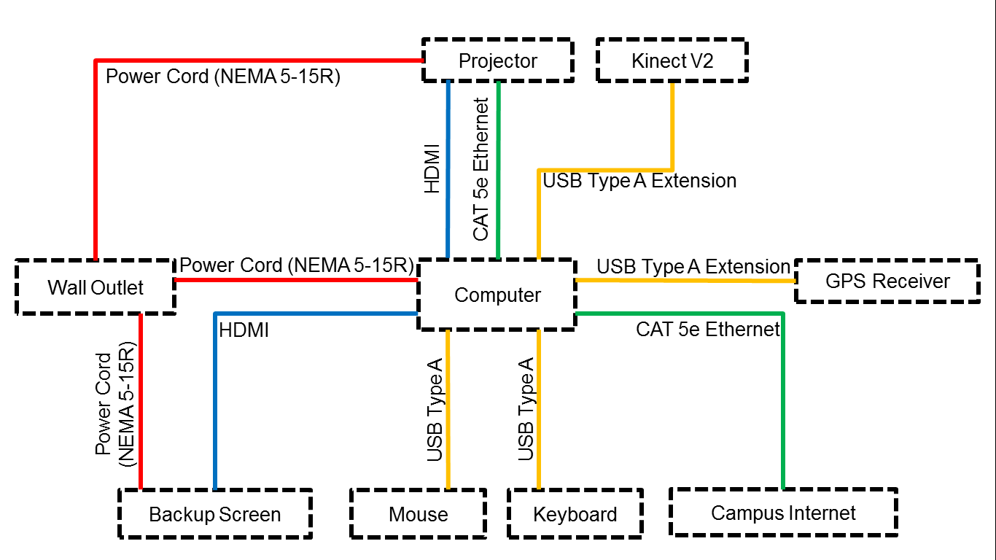

Figure : Connection Diagram

In total, the artifact computer needs ports to support 4 USB Type A connections, 2 Ethernet connections, 2 HDMI connections, and 1 power cord connection.

## App

The project team is developing an app in the C# language using the Unity Game Engine that will be run on the interactive screen. The app will create a global experience for the user by providing RSS new feeds of current news from around the world, information about countries of the world, a description of the Global Engineering RAP, geography and vocabulary games, weather reports (local and international), and more. The sources for the RSS news feeds will be selected carefully so that the content is appropriate and educational. The app will also be able to display content in several different languages to raise awareness of the world’s languages. Figure 10 below shows a screenshot of the app’s homepage.

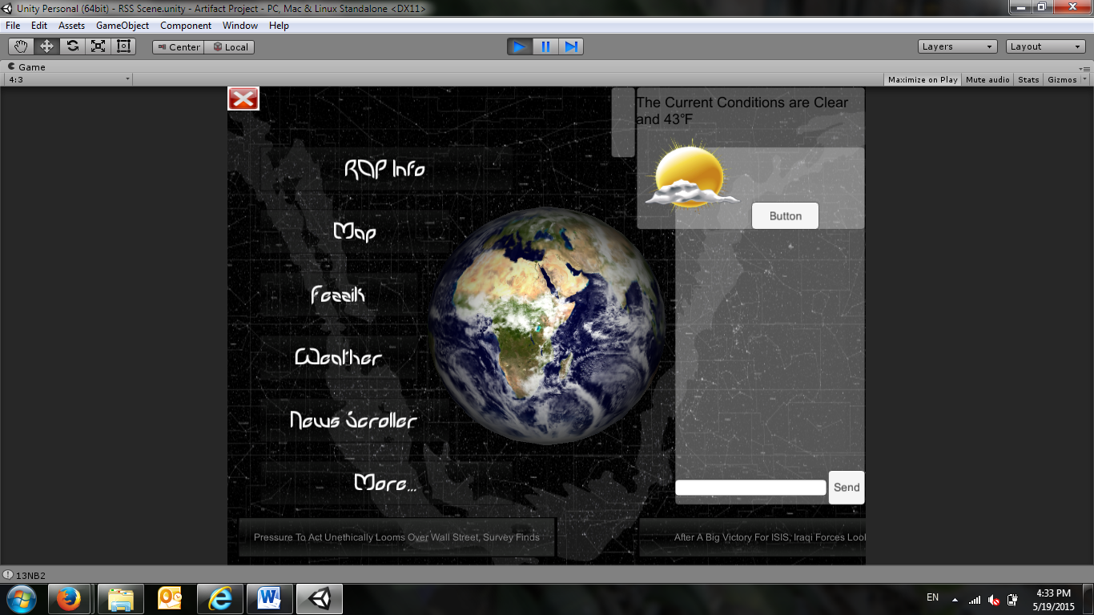

Figure : Screenshot of the App's Homepage

The app features a spinning globe with a background of stars. The buttons on the left side of the image provide access, global information, educational games, and other apps. Live news feeds are scrolling across the bottom on the screen. The user can select a news headline, and then the full story will open on the screen. The current weather for Boulder, Colorado, is displayed in the upper right side of the screen.

# Project Timeline and Key Deliverables

Planning for the Global Engineering artifact Project began in early April 2014. The project team was formed in early September 2014, and the design work began then. Design work continued throughout the fall semester. It is projected that parts could be ordered early in the spring semester of 2015 and the artifact if approved, will be built and tested through the spring of 2015. The end date of this project will be May 1, 2015, the end of the spring academic semester. Before this date, it is desired to have an official unveiling of the artifact. See the project timeline in Table 3 below.

Table : Timeline and Key Milestones

|  |  |  |
| --- | --- | --- |
| **Event** | **Date** | **Notes** |
| Project Begins | Early April 2014 | Begin planning and obtaining preliminary approvals |
| Student Design Team Formed | September 4, 2014 |  |
| Choose an Idea and Theme | October 2, 2014 | Chose an interactive touchscreen |
| Project Plan Completed | November 26, 2014 |  |
| Approval by Housing and others | December 2014 |  |
| Begin ordering parts | January and February 2015 |  |
| Install Artifact | March 2015 |  |
| Test and Refine | April 2015 |  |
| Official Unveiling | Late April 2015 |  |
| Project Completed | May 1, 2015 |  |

The key deliverables for this project will be a formal project proposal, design details (including engineering drawings, schematics, and code), the completed artifact, and an operator’s manual so Global Engineering students can maintain the artifact in future years.

# Project Budget

The budget for the artifact is shown below in Table 4.

Table : Artifact Budget

|  |  |
| --- | --- |
| Ubi Interactive Software (with educational discount) | $680 |
| Epson PowerLite 585W WXGA projector (with educational discount) | $1,200 |
| Replacement projector lamps(x3) | $250 |
| Kinect V2 Sensor | $180 |
| USGlobalSat BU-353-W | $34 |
| Computer Components  *-* GPU-GeForce GT 720  - WD RE2 500 GB internal hard drive Serial ATA-300 3.5’’ 7200 rpm  - Raidmax Smilodon atx-612wbp computer case with 500W power supply  - Intel® Core™ i5-4690 CPU/MSI Z97-G55 SLI ATX MB/8GB DDR3 1866 Kingston Hyper X  Fury Red Memory Bundle  - Cooler Master Hyper T2 - Compact CPU Cooler with Dual Looped Direct Contact Heat pipes  *Computer Total* | $60  $45  $100  $374  $16  *$595* |
| Cables  - 50 ft HDMI cable  - 50 ft USB Type A extension cable  - 50 ft USB Type A extension cable  - 50 ft Cat 5e Ethernet cable  - 25 ft Cat 5e Ethernet cable  - 40 ft Power cable | $28  $20  $20  $10  $5  $18 |
| **Total** | **$3,045** |

The projected cost for the artifact is $3,045. The Global Engineering RAP has approved a budged between $3,000 and $6,000. Since the preliminary costs for this project are about $3,000, the artifact is meeting its expected budget.

# Primary Stakeholders

The primary stakeholders for this project are described below. They are grouped by department or program.

* Housing and Dining
  + Paula Bland-Associate Director of Housing
    - Must approve any installation in Kitt Central
  + Victoria Vanderwerf-Kittredge Area Coordinator
    - Must approve any installation in Kitt Central
  + Nicole Stella-Kittredge Central Hall Director
    - Must approve any installation in Kitt Central
    - Will likely be the liaison to Facilities Management
* Facilities Management
  + Must approve any installation and building modifications in Kitt Central
* Global Engineering RAP
  + Dr. Diane Sieber-Global Engineering RAP Director
    - Must to approve the design and the budget
  + Will Derryberry-Project Manager
    - Must support the design
    - Monitor project scope, schedule, and budget
    - Attend weekly meetings with Dr. Sieber and run the individual project meetings
  + Student Design Team
    - Includes: Blain Vannice, Audrey Randall, Soham Shah, Darwin Wood, Ian Murphy, Sam Thornton, Mackinley Kath, Shannon Hessler, Charlie Vail, Connor Cheek, and Sean Downs
    - Design and build the artifact
* Residents in Kittredge Central
  + Will be the primary users of the artifact along with guests and visitors
* Herbst Faculty
  + Including: Dr. Leland Giovannelli and Dr. Scot Douglass
* Other Stakeholders
  + Katherine Pickens McConnell - Mechanical Engineering Advisor